Puzzle 1

Scan this QR code to get points:



*Agent Bunny:*

*I have the package but I’m under pursuit. I believe our comms are compromised. I’m going to leave a trail of breadcrumbs for you, but I need to keep on the move or the evil octopus Agents will get me. I’ll encode secret messages with the decoder system we share so you can use your cypher to decrypt the final answer. You’re going to have to solve puzzles to get each individual message though. Remember, you’ve got to get through all of these puzzles to secure the package, and keep the evil octopus Agents from getting access to the identities of all of our agents, yourself included. Hopefully this messages gets to you, Bunny. Agent Alpaca out.*

*- Agent Alpaca*

It looks like Agent Alpaca has been kidnapped before he could get his message to his fellow agent from the Agency! Now it’s up to our civilian heroes to retrieve that package! In the name of puzzles and world peace!

Scan this QR code to access the puzzle:

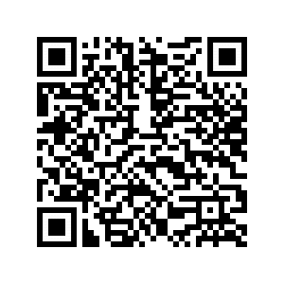

Puzzle 2

Scan this QR code to get points:



*Agent Bunny:*

*The evil octopus Agents almost got me when I wrote that first note, but I think I can keep ahead of them if I keep it brief. Luckily, they’ve missed the clues I’ve left behind--keep moving forward with them, and you’ll make it through!*

*Agent Alpaca*

Scan this QR code to access the puzzle:

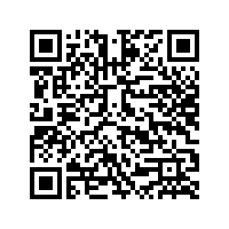

Puzzle 3

Scan this QR code to get points:

**

*Agent Bunny:*

*The evil octopodes are firmly unshaken, they’re still hot on my tail. I’m penning this to you quickly here; I take it if you’re reading it that you’ve uncovered the second breadcrumb--Good job, Agent Bunny, and keep on. You’ll need all seven pieces to secure the package.*

*Agent Alpaca*

Scan this QR code to access the puzzle:

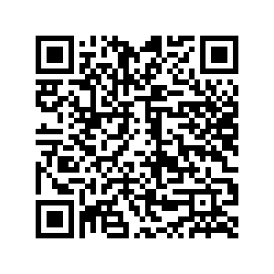

Puzzle 4

Scan this QR code to get points:

**

*Agent Bunny:*

*It’s possible I may have shaken them. I’m going to move slowly, but I’m going to try and take a more direct route to a nearby safe house. The next clue will lead you there unless something goes horribly wrong.*

* *Agent Alpaca*

Scan this QR code to access the puzzle:

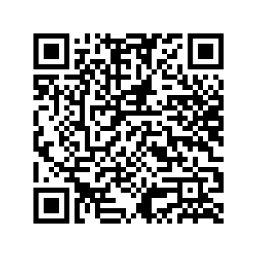

Puzzle 5

Scan this QR code to get points:



*Agent Bunny:*

*Something went horribly wrong! I found two octopodes at the safe house, and I couldn’t stay there. Agent Bunny, you’re going to have to steer clear of that location; the next puzzle piece will be at some other spot. Solve the clue and head for it now. I’m going to try some inconspicuous means of shaking these guys so I can make it to you.*

* *Agent Alpaca*

Scan this QR code to access the puzzle:

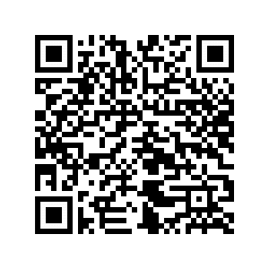

Puzzle 6

Scan this QR code to get points:



*Agent Bunny:*

*I managed to slim down the pursuing agents using some sleeper darts; they’ll turn up at the local police station with some incriminating documents attached. Unfortunately I did not have enough darts to get them all, so I have to keep moving.*

*Agent Alpaca*

Scan this QR code to access the puzzle:

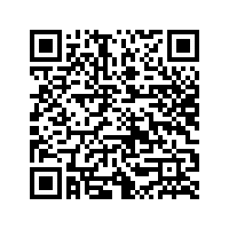

Puzzle 7

Scan this QR code to get points:



*Bunny:*

*This is your final note, and your penultimate breadcrumb. The final key is at the final location--use your cypher to put all the pieces together. Once you get through the final puzzle, bring the package back to HQ, where you started from. Keep the package out of the hands of the Rogue Agents--for the benefit of yourself and our fellow spies. Good luck, Agent!*

* *Agent Alpaca, signing off*

Scan this QR code to access the puzzle:

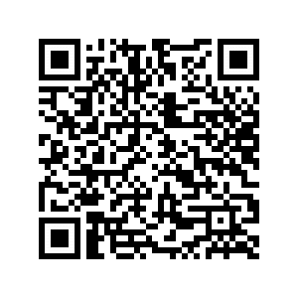

Final Puzzle

Scan this QR code to get points:

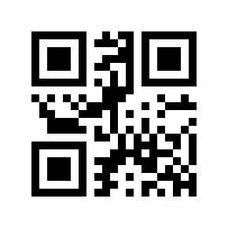

Scan this QR code to access the puzzle:

